Total Marks: | 4
Obtained Marks:

Web Technologies

Assignment # 04

Submitted To: Sir Zubair Ahmed
_______________________________________________________________________________________________________________________________________________________________________________________________________________________________________
Student Name: Ubaid Bin Waris
_______________________________________________________________________________________________________________________________________________________________________________________________________________________________________
Reg Number: 2212416 _______________________________________________________________________________________________________________________________________________________________________________________________________________________________________

Springboot Web app

Domain name





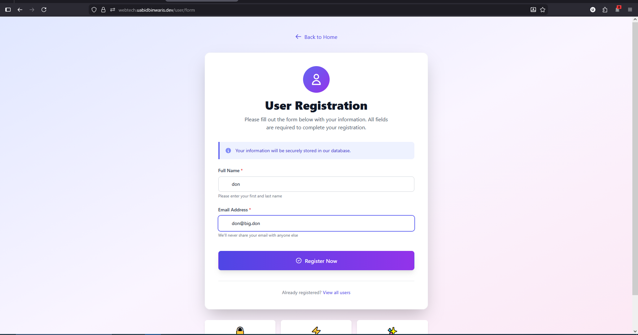

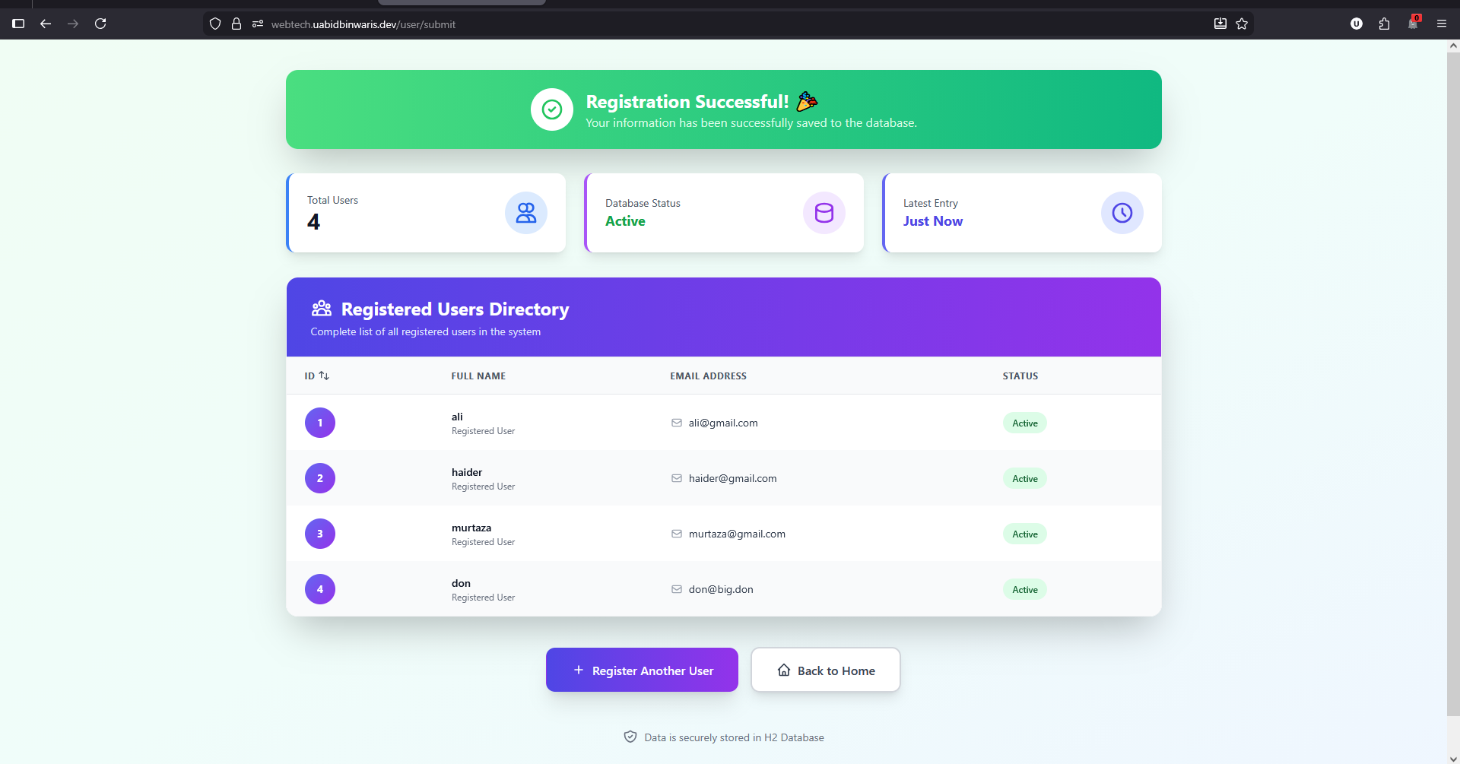

UserInfo.java

package com.example.model;
import jakarta.persistence.Entity;
import jakarta.persistence.GeneratedValue;
import jakarta.persistence.GenerationType;
import jakarta.persistence.Id;
@Entity
public class UserInfo {
@Id @GeneratedValue(strategy = GenerationType.IDENTITY)
private Long id;
private String name;
private String email;
public UserInfo() {
}
public UserInfo(String name, String email) {
this.name = name;
this.email = email;
}
public Long getId() {
return id;
}
public void setId(Long id) {
this.id = id;
}
// Getters and Setters (omitted for brevity, but required by Spring/Thymeleaf)
public String getName() { return name; }
public void setName(String name) { this.name = name; }
public String getEmail() { return email; }
public void setEmail(String email) { this.email = email; }
@Override
public String toString() {
return "UserInfo{name='" + name + "', email='" + email + "'}";
}
}

FormContorerl.java

package com.example.controller;
import com.example.model.UserInfo;
import com.example.service.UserInfoService;
import org.springframework.stereotype.Controller;
import org.springframework.ui.Model;
import org.springframework.web.bind.annotation.GetMapping;
import org.springframework.web.bind.annotation.ModelAttribute;
import org.springframework.web.bind.annotation.PostMapping;
@Controller
public class FormController {
private final UserInfoService userInfoService;
// Constructor injection
public FormController(UserInfoService userInfoService) {
this.userInfoService = userInfoService;
}
// Handles GET requests to /user/form (displays the blank form)
@GetMapping("/user/form")
public String showUserForm(Model model) {
// Adds an empty UserInfo object to the model for the Thymeleaf template
model.addAttribute("userInfo", new UserInfo());
return "userForm"; // Maps to userForm.html
}
// Handles POST requests to /user/submit (receives form data)
@PostMapping("/user/submit")
public String submitUserForm(@ModelAttribute("userInfo") UserInfo userInfo, Model model) {
// Spring binds form fields to the UserInfo object; the object is in the Model.
System.out.println("Received user info: " + userInfo.toString());
// Save the user info to the database
UserInfo savedUser = userInfoService.saveUserInfo(userInfo);
System.out.println("Saved to database with ID: " + savedUser.getId());
// Fetch all users from database and add to model
model.addAttribute("allUsers", userInfoService.getAllUsers());
return "userResult"; // Maps to userResult.html
}
}

HomeControler.java

package com.example.controller;
import org.springframework.stereotype.Controller;
import org.springframework.ui.Model;
import org.springframework.web.bind.annotation.GetMapping;
import org.springframework.web.bind.annotation.RequestParam;
@Controller
public class HomeControlller {
@GetMapping("/")
public String home(
@RequestParam(name="name", required=false, defaultValue="home") String name,
Model model // The Model object is used to pass data to the view
) {
// Add an attribute named "name" to the model
model.addAttribute("name", name);
// Return the *logical view name* ("home")
// Spring Boot/Thymeleaf resolves this to:
// src/main/resources/templates/home.html
return "home";
}
}

home.html

<!DOCTYPE html>
<html lang="en" xmlns:th="http://www.thymeleaf.org">
<head>
<meta charset="UTF-8">
<meta name="viewport" content="width=device-width, initial-scale=1.0">
<title>Welcome - Spring MVC Application</title>
<script src="https://cdn.tailwindcss.com"></script>
<style>
@keyframes blob {
0%,
100% {
transform: translate(0, 0) scale(1);
}
33% {
transform: translate(30px, -50px) scale(1.1);
}
66% {
transform: translate(-20px, 20px) scale(0.9);
}
}
.animate-blob {
animation: blob 7s infinite;
}
.animation-delay-2000 {
animation-delay: 2s;
}
.animation-delay-4000 {
animation-delay: 4s;
}
</style>
</head>
<body class="bg-gradient-to-br from-blue-50 via-indigo-50 to-purple-50 min-h-screen flex flex-col items-center justify-center p-4">
<!-- Animated Background Elements -->
<div class="absolute inset-0 overflow-hidden pointer-events-none">
<div class="absolute top-20 left-10 w-72 h-72 bg-purple-300 rounded-full mix-blend-multiply filter blur-xl opacity-20 animate-blob"></div>
<div class="absolute top-40 right-10 w-72 h-72 bg-yellow-300 rounded-full mix-blend-multiply filter blur-xl opacity-20 animate-blob animation-delay-2000"></div>
<div class="absolute bottom-20 left-1/2 w-72 h-72 bg-pink-300 rounded-full mix-blend-multiply filter blur-xl opacity-20 animate-blob animation-delay-4000"></div>
</div>
<div class="relative bg-white p-12 rounded-2xl shadow-2xl text-center max-w-2xl w-full border border-gray-100">
<!-- Header Icon -->
<div class="mb-6 flex justify-center">
<div class="bg-gradient-to-r from-blue-500 to-indigo-600 p-4 rounded-full">
<svg class="w-16 h-16 text-white" fill="none" stroke="currentColor" viewBox="0 0 24 24">
<path stroke-linecap="round" stroke-linejoin="round" stroke-width="2"
d="M12 4.354a4 4 0 110 5.292M15 21H3v-1a6 6 0 0112 0v1zm0 0h6v-1a6 6 0 00-9-5.197M13 7a4 4 0 11-8 0 4 4 0 018 0z">
</path>
</svg>
</div>
</div>
<h1 class="text-5xl font-extrabold bg-gradient-to-r from-blue-600 via-indigo-600 to-purple-600 bg-clip-text text-transparent mb-4">
<span th:text="${name} ? 'Hello, ' + ${name} + '!' : 'Welcome!'">Welcome!</span>
</h1>
<p class="text-gray-600 mb-6 text-lg leading-relaxed">
Welcome to our <strong class="text-indigo-600">Spring MVC Application</strong> powered by Thymeleaf.
We are delighted to have you here! This modern web application demonstrates the power of
Spring Boot with elegant form handling and database integration.
</p>
<div class="bg-blue-50 border-l-4 border-blue-500 p-4 mb-8 rounded-r-lg">
<p class="text-sm text-blue-700">
<strong>📝 Get Started:</strong> Click the button below to register your information
and join our community of users.
</p>
</div>
<a th:href="@{/user/form}"
class="inline-flex items-center justify-center bg-gradient-to-r from-blue-600 to-indigo-700 hover:from-blue-700 hover:to-indigo-800 text-white font-bold py-4 px-8 rounded-xl transition duration-300 ease-in-out transform hover:-translate-y-1 hover:shadow-xl shadow-lg">
<svg class="w-5 h-5 mr-2" fill="none" stroke="currentColor" viewBox="0 0 24 24">
<path stroke-linecap="round" stroke-linejoin="round" stroke-width="2"
d="M11 5H6a2 2 0 00-2 2v11a2 2 0 002 2h11a2 2 0 002-2v-5m-1.414-9.414a2 2 0 112.828 2.828L11.828 15H9v-2.828l8.586-8.586z">
</path>
</svg>
Go to Registration Form
</a>
<div class="mt-8 pt-8 border-t border-gray-200">
<p class="text-sm text-gray-500">
Built with Spring Boot, Thymeleaf & Tailwind CSS
</p>
</div>
</div>
</body>
</html>

userForm.html

<!DOCTYPE HTML>
<html lang="en" xmlns:th="http://www.thymeleaf.org">
<head>
<title>User Registration - Submit Your Information</title>
<meta http-equiv="Content-Type" content="text/html; charset=UTF-8" />
<meta name="viewport" content="width=device-width, initial-scale=1.0">
<script src="https://cdn.tailwindcss.com"></script>
</head>
<body class="bg-gradient-to-br from-indigo-100 via-purple-50 to-pink-100 min-h-screen flex items-center justify-center py-12 px-4 sm:px-6 lg:px-8">
<div class="max-w-2xl w-full space-y-8">
<!-- Back to Home Link -->
<div class="text-center">
<a th:href="@{/}" class="inline-flex items-center text-indigo-600 hover:text-indigo-800 transition duration-200">
<svg class="w-5 h-5 mr-2" fill="none" stroke="currentColor" viewBox="0 0 24 24">
<path stroke-linecap="round" stroke-linejoin="round" stroke-width="2" d="M10 19l-7-7m0 0l7-7m-7 7h18"></path>
</svg>
Back to Home
</a>
</div>
<!-- Main Form Container -->
<div class="bg-white p-10 rounded-2xl shadow-2xl border border-gray-100">
<!-- Header Section -->
<div class="text-center mb-8">
<div class="mx-auto w-20 h-20 bg-gradient-to-br from-indigo-500 to-purple-600 rounded-full flex items-center justify-center mb-4">
<svg class="w-10 h-10 text-white" fill="none" stroke="currentColor" viewBox="0 0 24 24">
<path stroke-linecap="round" stroke-linejoin="round" stroke-width="2" d="M16 7a4 4 0 11-8 0 4 4 0 018 0zM12 14a7 7 0 00-7 7h14a7 7 0 00-7-7z"></path>
</svg>
</div>
<h1 class="text-4xl font-extrabold text-gray-900 mb-3">
User Registration
</h1>
<p class="text-gray-600 text-base max-w-md mx-auto">
Please fill out the form below with your information. All fields are required to complete your registration.
</p>
</div>
<!-- Informational Alert -->
<div class="mb-6 bg-indigo-50 border-l-4 border-indigo-500 p-4 rounded-r-lg">
<div class="flex">
<div class="flex-shrink-0">
<svg class="h-5 w-5 text-indigo-400" fill="currentColor" viewBox="0 0 20 20">
<path fill-rule="evenodd" d="M18 10a8 8 0 11-16 0 8 8 0 0116 0zm-7-4a1 1 0 11-2 0 1 1 0 012 0zM9 9a1 1 0 000 2v3a1 1 0 001 1h1a1 1 0 100-2v-3a1 1 0 00-1-1H9z" clip-rule="evenodd"></path>
</svg>
</div>
<div class="ml-3">
<p class="text-sm text-indigo-700">
Your information will be securely stored in our database.
</p>
</div>
</div>
</div>
<!-- Registration Form -->
<form class="space-y-6" action="#" th:action="@{/user/submit}" th:object="${userInfo}" method="POST">
<!-- Name Field -->
<div>
<label for="name" class="block text-sm font-semibold text-gray-700 mb-2">
Full Name <span class="text-red-500">*</span>
</label>
<div class="relative">
<div class="absolute inset-y-0 left-0 pl-3 flex items-center pointer-events-none">
<svg class="h-5 w-5 text-gray-400" fill="none" stroke="currentColor" viewBox="0 0 24 24">
<path stroke-linecap="round" stroke-linejoin="round" stroke-width="2" d="M16 7a4 4 0 11-8 0 4 4 0 018 0zM12 14a7 7 0 00-7 7h14a7 7 0 00-7-7z"></path>
</svg>
</div>
<input type="text" id="name" th:field="*{name}" required
class="pl-10 appearance-none rounded-lg relative block w-full px-4 py-3 border border-gray-300 placeholder-gray-400 text-gray-900 focus:outline-none focus:ring-2 focus:ring-indigo-500 focus:border-transparent transition duration-200 sm:text-sm"
placeholder="Enter your full name">
</div>
<p class="mt-1 text-xs text-gray-500">Please enter your first and last name</p>
</div>
<!-- Email Field -->
<div>
<label for="email" class="block text-sm font-semibold text-gray-700 mb-2">
Email Address <span class="text-red-500">*</span>
</label>
<div class="relative">
<div class="absolute inset-y-0 left-0 pl-3 flex items-center pointer-events-none">
<svg class="h-5 w-5 text-gray-400" fill="none" stroke="currentColor" viewBox="0 0 24 24">
<path stroke-linecap="round" stroke-linejoin="round" stroke-width="2" d="M3 8l7.89 5.26a2 2 0 002.22 0L21 8M5 19h14a2 2 0 002-2V7a2 2 0 00-2-2H5a2 2 0 00-2 2v10a2 2 0 002 2z"></path>
</svg>
</div>
<input type="email" id="email" th:field="*{email}" required
class="pl-10 appearance-none rounded-lg relative block w-full px-4 py-3 border border-gray-300 placeholder-gray-400 text-gray-900 focus:outline-none focus:ring-2 focus:ring-indigo-500 focus:border-transparent transition duration-200 sm:text-sm"
placeholder="you@example.com">
</div>
<p class="mt-1 text-xs text-gray-500">We'll never share your email with anyone else</p>
</div>
<!-- Submit Button -->
<div class="pt-4">
<button type="submit"
class="group relative w-full flex justify-center items-center py-4 px-6 border border-transparent text-base font-semibold rounded-lg text-white bg-gradient-to-r from-indigo-600 to-purple-600 hover:from-indigo-700 hover:to-purple-700 focus:outline-none focus:ring-2 focus:ring-offset-2 focus:ring-indigo-500 transition duration-300 ease-in-out transform hover:-translate-y-0.5 shadow-lg hover:shadow-xl">
<svg class="w-5 h-5 mr-2" fill="none" stroke="currentColor" viewBox="0 0 24 24">
<path stroke-linecap="round" stroke-linejoin="round" stroke-width="2" d="M9 12l2 2 4-4m6 2a9 9 0 11-18 0 9 9 0 0118 0z"></path>
</svg>
Register Now
</button>
</div>
</form>
<!-- Footer Info -->
<div class="mt-8 pt-6 border-t border-gray-200">
<p class="text-center text-sm text-gray-500">
Already registered? <a th:href="@{/}" class="font-medium text-indigo-600 hover:text-indigo-500">View all users</a>
</p>
</div>
</div>
<!-- Additional Info Cards -->
<div class="grid grid-cols-1 md:grid-cols-3 gap-4 mt-8">
<div class="bg-white p-4 rounded-lg shadow-md text-center">
<div class="text-indigo-600 font-bold text-2xl mb-1">🔒</div>
<div class="text-sm font-semibold text-gray-700">Secure</div>
<div class="text-xs text-gray-500">Your data is encrypted</div>
</div>
<div class="bg-white p-4 rounded-lg shadow-md text-center">
<div class="text-indigo-600 font-bold text-2xl mb-1">⚡</div>
<div class="text-sm font-semibold text-gray-700">Fast</div>
<div class="text-xs text-gray-500">Instant registration</div>
</div>
<div class="bg-white p-4 rounded-lg shadow-md text-center">
<div class="text-indigo-600 font-bold text-2xl mb-1">✨</div>
<div class="text-sm font-semibold text-gray-700">Simple</div>
<div class="text-xs text-gray-500">Easy to use</div>
</div>
</div>
</div>
</body>
</html>

userResult.html

<!DOCTYPE html>
<html lang="en" xmlns:th="http://www.thymeleaf.org">
<head>
<meta charset="UTF-8">
<meta name="viewport" content="width=device-width, initial-scale=1.0">
<title>Registration Success - User Database</title>
<script src="https://cdn.tailwindcss.com"></script>
</head>
<body class="bg-gradient-to-br from-green-50 via-teal-50 to-blue-50 min-h-screen py-10 px-4 sm:px-6 lg:px-8">
<div class="max-w-6xl mx-auto">
<!-- Success Banner -->
<div class="mb-8 transform transition-all duration-500 hover:scale-105">
<div class="bg-gradient-to-r from-green-400 to-emerald-500 rounded-2xl shadow-2xl p-6 text-white">
<div class="flex items-center justify-center space-x-4">
<div class="bg-white rounded-full p-3">
<svg class="w-8 h-8 text-green-500" fill="none" stroke="currentColor" viewBox="0 0 24 24">
<path stroke-linecap="round" stroke-linejoin="round" stroke-width="2" d="M9 12l2 2 4-4m6 2a9 9 0 11-18 0 9 9 0 0118 0z"></path>
</svg>
</div>
<div>
<p class="text-2xl font-bold">Registration Successful! 🎉</p>
<p class="text-green-100">Your information has been successfully saved to the database.</p>
</div>
</div>
</div>
</div>
<!-- Statistics Cards -->
<div class="grid grid-cols-1 md:grid-cols-3 gap-6 mb-8">
<div class="bg-white rounded-xl shadow-lg p-6 border-l-4 border-blue-500 transform transition hover:scale-105">
<div class="flex items-center justify-between">
<div>
<p class="text-sm font-medium text-gray-600">Total Users</p>
<p class="text-3xl font-bold text-gray-900" th:text="${#lists.size(allUsers)}">0</p>
</div>
<div class="bg-blue-100 rounded-full p-3">
<svg class="w-8 h-8 text-blue-600" fill="none" stroke="currentColor" viewBox="0 0 24 24">
<path stroke-linecap="round" stroke-linejoin="round" stroke-width="2" d="M12 4.354a4 4 0 110 5.292M15 21H3v-1a6 6 0 0112 0v1zm0 0h6v-1a6 6 0 00-9-5.197M13 7a4 4 0 11-8 0 4 4 0 018 0z"></path>
</svg>
</div>
</div>
</div>
<div class="bg-white rounded-xl shadow-lg p-6 border-l-4 border-purple-500 transform transition hover:scale-105">
<div class="flex items-center justify-between">
<div>
<p class="text-sm font-medium text-gray-600">Database Status</p>
<p class="text-lg font-bold text-green-600">Active</p>
</div>
<div class="bg-purple-100 rounded-full p-3">
<svg class="w-8 h-8 text-purple-600" fill="none" stroke="currentColor" viewBox="0 0 24 24">
<path stroke-linecap="round" stroke-linejoin="round" stroke-width="2" d="M4 7v10c0 2.21 3.582 4 8 4s8-1.79 8-4V7M4 7c0 2.21 3.582 4 8 4s8-1.79 8-4M4 7c0-2.21 3.582-4 8-4s8 1.79 8 4"></path>
</svg>
</div>
</div>
</div>
<div class="bg-white rounded-xl shadow-lg p-6 border-l-4 border-indigo-500 transform transition hover:scale-105">
<div class="flex items-center justify-between">
<div>
<p class="text-sm font-medium text-gray-600">Latest Entry</p>
<p class="text-lg font-bold text-indigo-600">Just Now</p>
</div>
<div class="bg-indigo-100 rounded-full p-3">
<svg class="w-8 h-8 text-indigo-600" fill="none" stroke="currentColor" viewBox="0 0 24 24">
<path stroke-linecap="round" stroke-linejoin="round" stroke-width="2" d="M12 8v4l3 3m6-3a9 9 0 11-18 0 9 9 0 0118 0z"></path>
</svg>
</div>
</div>
</div>
</div>
<!-- Users Table -->
<div class="bg-white shadow-2xl rounded-2xl overflow-hidden border border-gray-100">
<div class="px-8 py-6 bg-gradient-to-r from-indigo-600 to-purple-600 border-b border-gray-200">
<div class="flex items-center justify-between">
<div>
<h2 class="text-2xl font-bold text-white flex items-center">
<svg class="w-7 h-7 mr-3" fill="none" stroke="currentColor" viewBox="0 0 24 24">
<path stroke-linecap="round" stroke-linejoin="round" stroke-width="2" d="M17 20h5v-2a3 3 0 00-5.356-1.857M17 20H7m10 0v-2c0-.656-.126-1.283-.356-1.857M7 20H2v-2a3 3 0 015.356-1.857M7 20v-2c0-.656.126-1.283.356-1.857m0 0a5.002 5.002 0 019.288 0M15 7a3 3 0 11-6 0 3 3 0 016 0zm6 3a2 2 0 11-4 0 2 2 0 014 0zM7 10a2 2 0 11-4 0 2 2 0 014 0z"></path>
</svg>
Registered Users Directory
</h2>
<p class="text-indigo-100 text-sm mt-1">Complete list of all registered users in the system</p>
</div>
</div>
</div>
<div class="overflow-x-auto">
<table class="min-w-full divide-y divide-gray-200">
<thead class="bg-gray-50">
<tr>
<th scope="col" class="px-6 py-4 text-left text-xs font-bold text-gray-600 uppercase tracking-wider">
<div class="flex items-center space-x-1">
<span>ID</span>
<svg class="w-4 h-4" fill="none" stroke="currentColor" viewBox="0 0 24 24">
<path stroke-linecap="round" stroke-linejoin="round" stroke-width="2" d="M7 16V4m0 0L3 8m4-4l4 4m6 0v12m0 0l4-4m-4 4l-4-4"></path>
</svg>
</div>
</th>
<th scope="col" class="px-6 py-4 text-left text-xs font-bold text-gray-600 uppercase tracking-wider">
<div class="flex items-center space-x-1">
<span>Full Name</span>
</div>
</th>
<th scope="col" class="px-6 py-4 text-left text-xs font-bold text-gray-600 uppercase tracking-wider">
<div class="flex items-center space-x-1">
<span>Email Address</span>
</div>
</th>
<th scope="col" class="px-6 py-4 text-left text-xs font-bold text-gray-600 uppercase tracking-wider">Status</th>
</tr>
</thead>
<tbody class="bg-white divide-y divide-gray-200">
<tr th:each="user, iterStat : ${allUsers}"
class="hover:bg-indigo-50 transition duration-200 transform hover:scale-[1.01]"
th:classappend="${iterStat.index % 2 == 0} ? 'bg-white' : 'bg-gray-50'">
<td class="px-6 py-4 whitespace-nowrap">
<div class="flex items-center">
<div class="flex-shrink-0 h-10 w-10 bg-gradient-to-br from-indigo-500 to-purple-600 rounded-full flex items-center justify-center">
<span class="text-white font-bold text-sm" th:text="${user.id}">1</span>
</div>
</div>
</td>
<td class="px-6 py-4 whitespace-nowrap">
<div class="flex items-center">
<div>
<div class="text-sm font-semibold text-gray-900" th:text="${user.name}">John Doe</div>
<div class="text-xs text-gray-500">Registered User</div>
</div>
</div>
</td>
<td class="px-6 py-4 whitespace-nowrap">
<div class="flex items-center">
<svg class="w-4 h-4 mr-2 text-gray-400" fill="none" stroke="currentColor" viewBox="0 0 24 24">
<path stroke-linecap="round" stroke-linejoin="round" stroke-width="2" d="M3 8l7.89 5.26a2 2 0 002.22 0L21 8M5 19h14a2 2 0 002-2V7a2 2 0 00-2-2H5a2 2 0 00-2 2v10a2 2 0 002 2z"></path>
</svg>
<span class="text-sm text-gray-700" th:text="${user.email}">john@example.com</span>
</div>
</td>
<td class="px-6 py-4 whitespace-nowrap">
<span class="px-3 py-1 inline-flex text-xs leading-5 font-semibold rounded-full bg-green-100 text-green-800">
Active
</span>
</td>
</tr>
</tbody>
</table>
</div>
<!-- Empty State -->
<div th:if="${#lists.isEmpty(allUsers)}" class="text-center py-12">
<svg class="mx-auto h-12 w-12 text-gray-400" fill="none" stroke="currentColor" viewBox="0 0 24 24">
<path stroke-linecap="round" stroke-linejoin="round" stroke-width="2" d="M20 13V6a2 2 0 00-2-2H6a2 2 0 00-2 2v7m16 0v5a2 2 0 01-2 2H6a2 2 0 01-2-2v-5m16 0h-2.586a1 1 0 00-.707.293l-2.414 2.414a1 1 0 01-.707.293h-3.172a1 1 0 01-.707-.293l-2.414-2.414A1 1 0 006.586 13H4"></path>
</svg>
<h3 class="mt-2 text-sm font-medium text-gray-900">No users found</h3>
<p class="mt-1 text-sm text-gray-500">Get started by registering a new user.</p>
</div>
</div>
<!-- Action Buttons -->
<div class="mt-10 flex flex-col sm:flex-row gap-4 justify-center items-center">
<a th:href="@{/user/form}"
class="inline-flex items-center px-8 py-4 border border-transparent text-base font-semibold rounded-xl text-white bg-gradient-to-r from-indigo-600 to-purple-600 hover:from-indigo-700 hover:to-purple-700 focus:outline-none focus:ring-2 focus:ring-offset-2 focus:ring-indigo-500 transition duration-300 transform hover:-translate-y-1 shadow-xl hover:shadow-2xl">
<svg class="w-5 h-5 mr-2" fill="none" stroke="currentColor" viewBox="0 0 24 24">
<path stroke-linecap="round" stroke-linejoin="round" stroke-width="2" d="M12 6v6m0 0v6m0-6h6m-6 0H6"></path>
</svg>
Register Another User
</a>
<a th:href="@{/}"
class="inline-flex items-center px-8 py-4 border-2 border-gray-300 text-base font-semibold rounded-xl text-gray-700 bg-white hover:bg-gray-50 focus:outline-none focus:ring-2 focus:ring-offset-2 focus:ring-indigo-500 transition duration-300 transform hover:-translate-y-1 shadow-lg hover:shadow-xl">
<svg class="w-5 h-5 mr-2" fill="none" stroke="currentColor" viewBox="0 0 24 24">
<path stroke-linecap="round" stroke-linejoin="round" stroke-width="2" d="M3 12l2-2m0 0l7-7 7 7M5 10v10a1 1 0 001 1h3m10-11l2 2m-2-2v10a1 1 0 01-1 1h-3m-6 0a1 1 0 001-1v-4a1 1 0 011-1h2a1 1 0 011 1v4a1 1 0 001 1m-6 0h6"></path>
</svg>
Back to Home
</a>
</div>
<!-- Footer Info -->
<div class="mt-12 text-center">
<div class="inline-flex items-center space-x-2 text-sm text-gray-500">
<svg class="w-5 h-5" fill="none" stroke="currentColor" viewBox="0 0 24 24">
<path stroke-linecap="round" stroke-linejoin="round" stroke-width="2" d="M9 12l2 2 4-4m5.618-4.016A11.955 11.955 0 0112 2.944a11.955 11.955 0 01-8.618 3.04A12.02 12.02 0 003 9c0 5.591 3.824 10.29 9 11.622 5.176-1.332 9-6.03 9-11.622 0-1.042-.133-2.052-.382-3.016z"></path>
</svg>
<span>Data is securely stored in H2 Database</span>
</div>
<p class="mt-4 text-xs text-gray-400">
Built with Spring Boot 3, Thymeleaf & Tailwind CSS • © 2025
</p>
</div>
</div>
</body>
</html>

Application.properties

spring.application.name=ass4
spring.datasource.url=jdbc:postgresql://localhost:5432/web_database
spring.datasource.username=web_user
spring.datasource.password=web_password
# The driver class name is usually auto-detected by Spring Boot, but you can specify it explicitly:
# spring.datasource.driver-class-name=org.postgresql.Driver
# 2. JPA/Hibernate Configuration
# This tells Hibernate how to translate SQL for PostgreSQL dialect
spring.jpa.properties.hibernate.dialect=org.hibernate.dialect.PostgreSQLDialect
# Optional: show SQL in the console (useful for debugging)
spring.jpa.show-sql=true
# Optional: configure database schema actions
# 'none', 'validate', 'update', 'create', 'create-drop'
spring.jpa.hibernate.ddl-auto=update

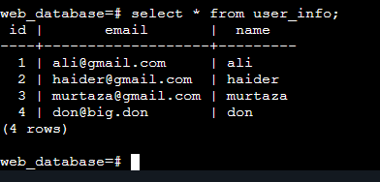

Apache Configuration Files

Below are the full files (path + copy–paste content). Put these exact contents into the files on your server.

/etc/apache2/sites-available/000-default.conf

This is the default site — it proxies all requests to Tomcat on localhost:8080 and blocks access to /manager.

<VirtualHost *:80>
# Proxy all requests to Tomcat
ProxyPreserveHost On
ProxyPass / http://127.0.0.1:8080/
ProxyPassReverse / http://127.0.0.1:8080/

# Optional: prevent direct access to Tomcat manager via Apache
<Location /manager>
Require all denied
</Location>

ErrorLog ${APACHE_LOG_DIR}/error.log
CustomLog ${APACHE_LOG_DIR}/access.log combined
</VirtualHost>

Save the file and enable the site (if not already):

sudo a2ensite 000-default.conf
sudo systemctl reload apache2

/etc/apache2/sites-available/webtech.conf

This virtual host handles HTTP for your domain and redirects to HTTPS.

<VirtualHost *:80>
ServerName webtech.uabidbinwaris.dev
ServerAlias www.webtech.uabidbinwaris.dev

ProxyRequests Off
ProxyPreserveHost On
ProxyPass / http://127.0.0.1:8080/
ProxyPassReverse / http://127.0.0.1:8080/

ErrorLog ${APACHE_LOG_DIR}/webtech-error.log
CustomLog ${APACHE_LOG_DIR}/webtech-access.log combined

RewriteEngine on
RewriteCond %{SERVER_NAME} =webtech.uabidbinwaris.dev [OR]
RewriteCond %{SERVER_NAME} =www.webtech.uabidbinwaris.dev
RewriteRule ^ https://%{SERVER_NAME}%{REQUEST_URI} [END,NE,R=permanent]
</VirtualHost>

Enable and reload:

sudo a2ensite webtech.conf
sudo systemctl reload apache2

/etc/apache2/sites-available/webtech-le-ssl.conf

This virtual host serves HTTPS and points Apache to the Let's Encrypt certificates.

<IfModule mod_ssl.c>
<VirtualHost *:443>
ServerName webtech.uabidbinwaris.dev
ServerAlias www.webtech.uabidbinwaris.dev

ProxyRequests Off
ProxyPreserveHost On
ProxyPass / http://127.0.0.1:8080/
ProxyPassReverse / http://127.0.0.1:8080/

ErrorLog ${APACHE_LOG_DIR}/webtech-error.log
CustomLog ${APACHE_LOG_DIR}/webtech-access.log combined

Include /etc/letsencrypt/options-ssl-apache.conf
SSLCertificateFile /etc/letsencrypt/live/webtech.uabidbinwaris.dev/fullchain.pem
SSLCertificateKeyFile /etc/letsencrypt/live/webtech.uabidbinwaris.dev/privkey.pem
</VirtualHost>
</IfModule>

Enable the SSL site and reload Apache:

sudo a2ensite webtech-le-ssl.conf
sudo systemctl reload apache2

Restart Apache:

sudo apachectl configtest
sudo systemctl restart apache2

